Confirmation: Club „Plungės dziudo“ 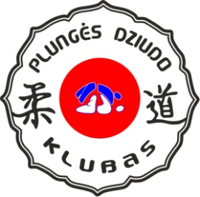 Plungė Sports and Recreation Center
Chairman Antanas Kasteckas Director Alvydas Viršilas

VIII YOUTH INTERNATIONAL JUDO TOURNAMENT „PAVASARIS 2015“
IN MEMORIAM OF JUDO COACH KĘSTUTIS ŠERMUKŠNIS

R E G U L A T I O N S

1.Goals of the competition:
1.1. to popularize judo wrestling in the disctrict of Plungė;
1.2. to raise the skill of young judo wrestlers;
1.3. to maintain friendly relations with other judo clubs, towns and countries;
1.4. to honor coach KĘSTUTIS ŠERMUKŠNIS.
2.The time, date and place of competition:
2.1. Date: May 23, 2015.
2.2. Place: Telšių str. 24 a, Plungė.
2.3. Wheigh in: 9.00 am - 10.00 am.
2.4. Start of the competition – 11.00 am.

3. Age of participants:
3.1. Young men, (born 1999-2002) .
4. Weight categories:
4.1. -35kg, -38kg, -42kg, -46kg,-50kg, -55kg, -60kg, -66 kg, -73kg, -81kg,-90kg, +90kg.
( 500 grams of extra-weight allowed).
Number of participants is unlimited.
Wrestlers from Lithuania, Latvia and Estonia are invited to participate.

PARTICIPATION FEE (6 Euro) FOR EACH INDIVIDUAL.
5.1. Competition is held by „Plungės dziudo“ club and Plungė Sports and Recreation Center;
5.2. the competition is executed by a certified board of referees;
5.3. winners are determined in accordance with the active rules of IJF.
6. Awards:
6.1. champions in each weight category will be awarded cups, diplomas, medals; 2nd and 3rd place winners – diplomas and medals.
7. Reception condintions:
7.1. expenses, associated with participation are to be covered by the sending organization.
8. Applications:
8.1. applications should be emailed to akasteckas@gmail.com until May 21;
8.2. applications confirmed by a doctor should be directly presented to the senior referee on the day of the competition;
8.3. wrestlers must have valid health insurance;
8.4. it is preferable for each club to bring a referee.

Information for enquiries - coach Antanas Kasteckas +37060404855 , email akasteckas@gmail.com

Organizers

